To Athletic/Band Parents:

The Frenship High School Sports Medicine Staff would like to welcome you to another year of Frenship ISD athletics/band. To ensure your child’s health and eligibility, we have assembled a packet of all necessary paperwork REQUIRED for participation in any and all sports and high school marching band.

Fill out required forms electronically through Rank One Sport by going to frenshipisd.rankone.com (see reverse side for instructions). The medical history and physical examination forms attached must be completed and signed by a licensed physician and turned in.

FAILURE TO PROPERLY AND COMPLETELY FILL-OUT AND SIGN ALL FORMS COULD RESULT IN YOUR CHILD BEING INELIGIBLE TO PARTICIPATE IN ATHLETICS/BAND!

Your child will need a new physical examination if he/she will be in 7th through the 12th grade for the upcoming school year. The medical history portion of the physical form must be completed and signed before your child will be seen by a physician. The schedule for the physicals is:

Middle School Dates: Frenship High School Date:
Tuesday April 7th Tuesday April 7th
10:00 AM Frenship Middle School 7:00 AM Football
7:45 AM Freshman
Tuesday April 21st 8:15 AM Sophomores
10:00 AM Alcove Trails Middle School 8:45 AM Juniors

**Physicals for FHS/FMS @ FHS Field House; Physicals for ATMS @ ATMS Campus**

The cost of the physical exam is $20.00 (make checks payable to FHS Booster Club). This event is not mandatory and students may obtain their physicals from other healthcare providers. The medical professionals providing this service to Frenship ISD are the physicians and residents from Texas Tech Pediatrics. The physical MUST be on the most current physical exam form, released by the UIL in 2026 (PLEASE use attached form). You can also access the form online at http://www.uil.utexas.edu/athletics/forms.

If you have any questions or need to reach us for any reason, please do not hesitate to contact us at the Athletic Office 866-4480. Thank you for your support and cooperation.

Sincerely,

Frenship High School Sports Medicine Staff

RankOne Parent Click Sheet
Go to frenshipisd.rankone.com
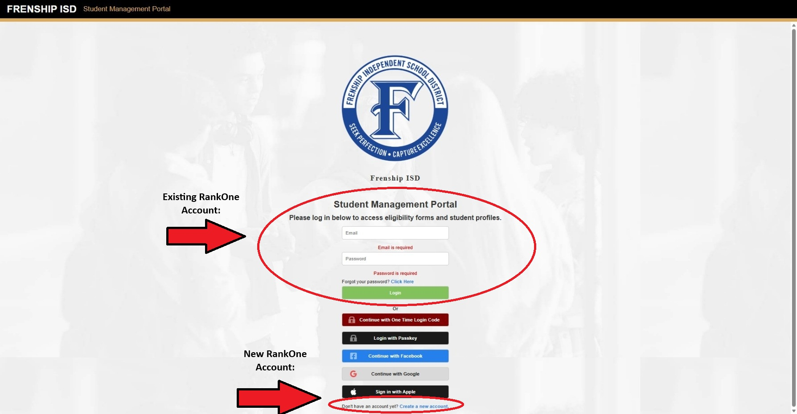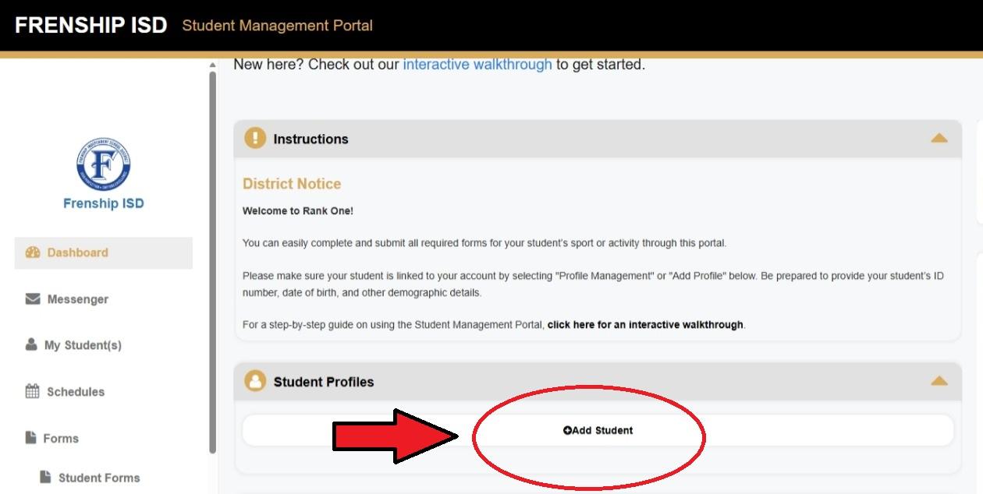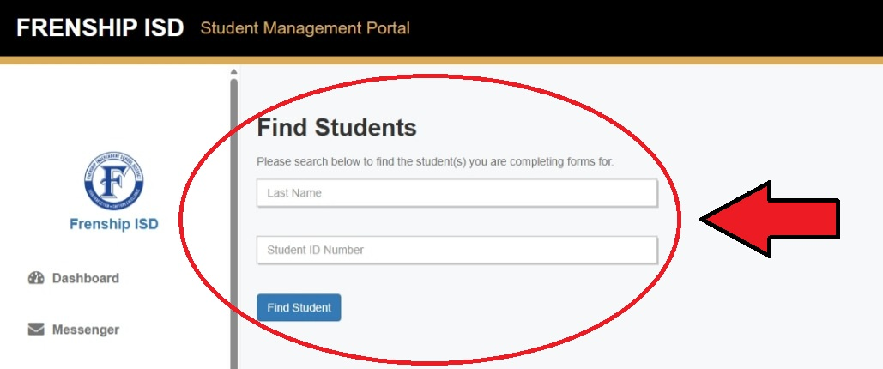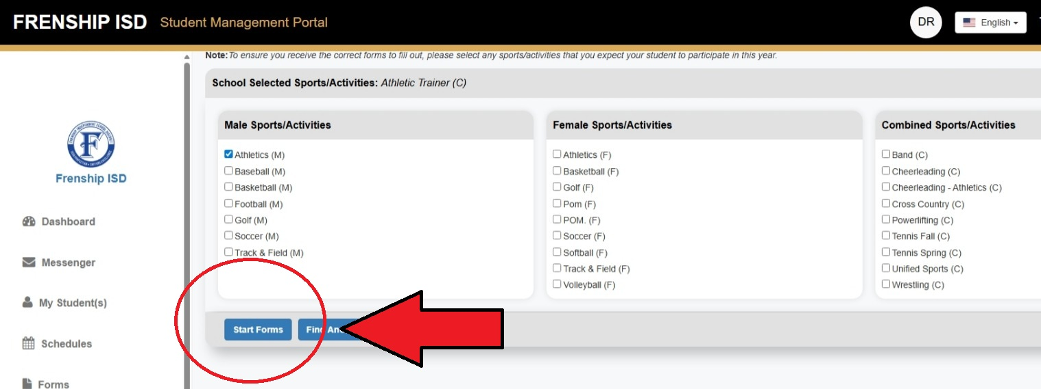
Step 4:

Click on student’s name, select sport(s) or simply click athletics, next click Start Forms.

*For multiple student’s you will need to create a profile for each student by following steps 2 – 4.
Step 2:

Once account email has been verified. Login into parent portal and you will need to add your student (see picture)

*If your student already appears here skip to step 4
Step 1:

Existing Users:
proceed to login
(forgot password to reset)

New Users:
Create an account bottom of page
Step 3:

Search for your student using their legal last name and student ID. Click find student, next Click Add student to profile.
PLEASE COMPLETE ALL FORMS!

